St. Maarten Montessori School
2022-2023
Calendar
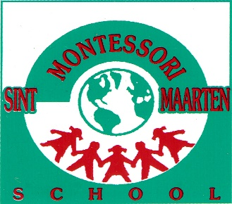

August 2022
August 01 – Mon | First day of school for teachers – Staff Orientation
August 05 – Fri | New Students Orientation
August 08 – Mon | First day of school for all students
September 2022
September 02 – Fri | Parent Orientation and Education Evening 6:00 p.m.
September 30 – Fri | Interim Progress Reports sent home
October 2022
October 03 – 07 | (Monday – Friday) Mid-Term Break (no school)
October 10 – Mon | Constitution Day (no school)
October 11 – Tue | School Resumes
November 2022
November 11 – Fri | St. Maarten Day (no school)
November 14 – Mon | School Resumes
November 18 – Fri | Upper Elementary Thanksgiving Event
Nov 28 – Dec 01 | (Monday – Thursday) Parent Observation Week
December 2022 | School Community Project: Gift & Food Drive
December | Holiday Show to be announced
December 08 – Thurs | Progress Reports sent home
December 09 – Fri | Parent/Teacher Conference (no school)
December 16 – Fri | Potluck Lunch/Holiday Break (12:00 noon dismissal)
December 19 – Jan 09 | (Monday – Friday) Christmas Vacation (no school)
January 2023
January 06 – Fri | Teacher Professional Day
January 09 – Mon | School Resumes
February 2023
February 20 – 21 | (Monday – Tuesday) Mid-Term Break (no school)
February 22 – Wed | School Resumes
March 2023 | Enrollment Month
March 17 – Fri | Interim Progress Reports sent home
March 24 – Fri | Tea with Mom
April 2023
April 06 – 10 | (Thursday – Monday) Easter Break (no school)
April 11 – Tues | School Resumes
April 21 – Fri | Fine Arts Night
April 24 – May 05 | (Monday – Friday) Carnival Break (no school)
May 2023
May 08 – Mon | School Resumes
May 18 – 19 | (Thursday – Friday) Ascension Day (no school)
May 22 – Mon | School Resumes
May 26 – Fri | Pancakes with Dad
June 2023 | End of the Year Recital
June 08 – Thurs | Progress Reports Sent Home
June 09 – Fri | Parent/Teacher Conference (no school)
June 13 – Tue | Sixth Grade Graduation
June 16 – Fri | Last day of school (12:00 noon dismissal)
June 19 – August 04 | (Monday – Friday) Summer Vacation
June 21 - Wed | Last day of school for teachers
July 2023
July 31 – Mon | First day of school for Staff
August 2023
August 04 – Fri | New Students Orientation
August 07 – Mon | First day of school for Students

*Vacation Days*

